**Reading Festival**

The Reading and Leeds Festivals are a pair of annual [music festivals](https://en.wikipedia.org/wiki/Music_festival) that take place in [Reading](https://en.wikipedia.org/wiki/Reading,_Berkshire) and [Leeds](https://en.wikipedia.org/wiki/Leeds) in England. The events take place simultaneously on the Friday, Saturday and Sunday of the August [bank holiday](https://en.wikipedia.org/wiki/Bank_holiday) weekend. The Reading Festival is held at Little John's Farm on Richfield Avenue in central Reading, near [Caversham Bridge](https://en.wikipedia.org/wiki/Caversham_Bridge). The Leeds event is held in [Bramham Park](https://en.wikipedia.org/wiki/Bramham_Park), near [Wetherby](https://en.wikipedia.org/wiki/Wetherby), the grounds of a historic house. Headliners and most supporting acts typically play at both sites, with Reading's Friday line up becoming Leeds' Saturday line-up, Reading's Saturday line-up playing at Leeds on Sunday, and Leeds' Friday line-up attending Reading on Sunday. Campsites are available at both sites and weekend tickets include camping. Day tickets are also sold.

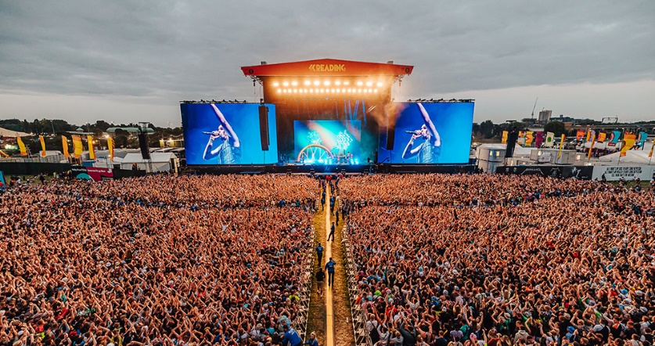

The Reading Festival, the older of the two festivals, is the longest-running popular music festival in the UK. Many of the biggest bands in the UK and internationally have played at the festival over five decades. The festival has had various musical phases over the years, but since the current two-site format was adopted in 1999, rock, [alternative](https://en.wikipedia.org/wiki/Alternative_rock), [indie](https://en.wikipedia.org/wiki/Indie_rock), [punk](https://en.wikipedia.org/wiki/Punk_rock), and [metal](https://en.wikipedia.org/wiki/Metal_music) have been the main genres featured in the line-up. More recently [hip hop](https://en.wikipedia.org/wiki/Hip_hop) has comprised an increasing proportion of the lineup, including headline sets by artists such as [Kendrick Lamar](https://en.wikipedia.org/wiki/Kendrick_Lamar) and [Post Malone](https://en.wikipedia.org/wiki/Post_Malone).

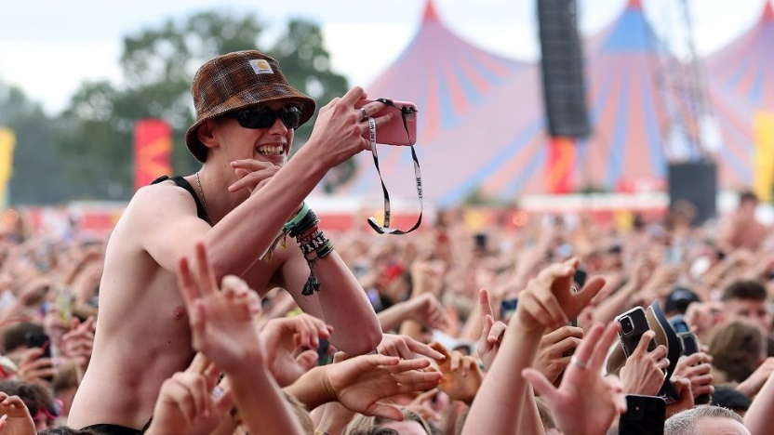

The festivals are run by [Festival Republic](https://en.wikipedia.org/wiki/Festival_Republic), which was divested from Mean Fiddler Music Group. From 1998 to 2007, the festivals were known as the *Carling Weekend: Reading* and the *Carling Weekend: Leeds* for promotional purposes. In November 2007, the sponsored title was abolished after nine years and the Reading Festival reclaimed its original name. In 2011, the capacity of the Reading site was 87,000, and the Leeds site was 75,000, an increase of several thousand on previous years.